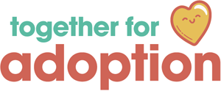

**Consent to Share Information.**

* I/we give my/our consent to TFA consulting with relevant agencies in order to obtain information regarding my/my child(ren)’s birth history and pre/post-adoption experiences.
* I/we give my/our consent to TFA sharing my/our Assessment of Adoption Support Needs and Support Plan to relevant professionals.
* I/we understand that the assessment may lead to an Adoption Support Fund Application, using my/our child(ren’s) fair access amount of funding.
* I/we agree to maintain confidentiality of any virtual sessions with TFA employees, and will not video record sessions without prior discussion and written consent from TFA.
* I/We agree for our names and email address to be added to TFA’s mailing list.

|  |  |
| --- | --- |
| Name of Child(ren): |  |
| Consent Given By: |  |
| Position: |  |
| Parents Signature:  TFA Worker |  |
| TFA Signature |  |
| Position: |  |
| Date: |  |