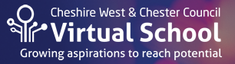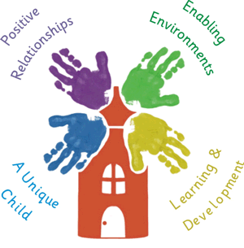

**TRANSITION**

Transition describes the movement that takes place from one educational setting to another, through from Pre-school to Year 12. For Children and Young People in Care, Previously in Care and Care Leavers leaving one educational setting and settling in to their new learning environment can be especially unsettling and so a well planned and executed transition is essential.

Rapid change can lead to insecurity and worries which can in turn inhibit a child’s attitude to school and affect wellbeing and learning. Vulnerable young people may have other difficult experiences in their lives, past, present or both and can struggle with existing attachments or the ability to make new relationships that they need or rely on.

As a Virtual School we our children in care to experience smooth transitions so that the quality of learning is maintained and they can continue to make the very best progress, as well as maintaining or building key relationships and attachments to enhance, support and maintain their confidence, self esteem and wellbeing.

The sharing of key and pertinent information in a sensitive and appropriate way is vital in order to maximise a successful transition. Although the child’s voice should be paramount in transition it is recommended that a CiC has opportunities above and beyond the regular transition visit of his / her cohort to their new school in order to build confidence and lesson any anxiety.

Examples of confidential information that can be shared as appropriate at a vulnerable young person’s Transition Meeting:

Pupil’s One Page Profile

Passport to Success/ Activity Passport  
Contextual information  
Wellbeing information and details of support in place

Details of key relationships and attachments

Requirements to support new key relationships and attachments  
Personal Education Plans (PEPs)  
Completed Pupil Progress Summary (for current year), identifying past and current interventions  
Pupil Progress Summary for coming year, identifying interventions planned for the next Term   
Attainment Data for Reading, Writing and Maths   
SEND information: Individual Pupil Profiles, details of SEND support and funding, EHCPs

Record of Interventions held or planned  
Important Medical information

**It should be noted that this is not an exhaustive list as each vulnerable young person’s transition is unique and comes with its own challenges, requirements and expectations.**