

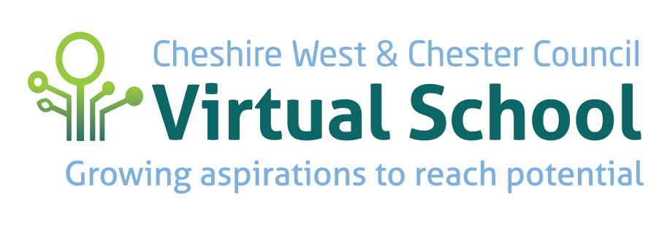

**Information for Young People**

What is a Virtual School?

The Virtual School is a team of teachers who work for and with children in care and young people in education.

What do we do?

* We make sure your Personal Education Plan (PEP) will help you to do your best in school
* We talk to your school, your college, your social worker and your carer to find out how you are doing
* We talk with you to find out how things are going
* Support could be offered in the classroom, in a small group or one-to-one
* We can help you with resources to support your education
* If you are going to move school or college, we will help you, your carer and social worker find a new one that’s right for you
* If you are finding it difficult to go to school or college, we will do our best to encourage and support your return

What else do you need to know?

* In your school or college there will be a teacher who has special responsibility for children in care. This is the Designated Teacher for children and young people in care.
* Every looked after young person must have a termly PEP which you should attend or you should be invited to attend
* Your school, college or employer and social worker will write the PEP, with your help
* After the meeting somebody will go through your PEP with you and you are entitled to a copy

If you do not attend your PEP meeting you should tell your designated teacher, social worker or your carer how you feel about your education and anything you want them to know about you. **It is very important to make sure you have your say.**



What is Pupil Premium Plus?

Pupil Premium Plus is money The Virtual School receive from the government which is to support the wellbeing and education of children and young people in care from Reception to Year 11. For younger children, there is Early Years Pupil Premium which is available the school term after your third birthday.

You are eligible for Pupil Premium Plus or Early Years Pupil Premium from the first day of care.

Requests for both Pupil Premium Plus and Early Years Pupil Premium are made through your Personal Education Plan (PEP).

Pupil Premium Plus must be used to help you do well in school and get the very best results. There is no set amount which means we can provide the best support for you. This will be decided by the adults working with you as part of the discussion in your PEP meeting.

In your termly Personal Education Plan (PEP) your designated teacher, social worker, carer will discuss with you and plan how your Pupil Premium Plus will be spent to best support your education.

**More information can be found on our Virtual School Website: www.cheshirewestvirtual.school**

